Major Project

On

Capgemini Classifieds

Submitted by

JavaScript Full Stack batch

(Started on June 13th2018)

Under the guidance of

Aditya Bokade

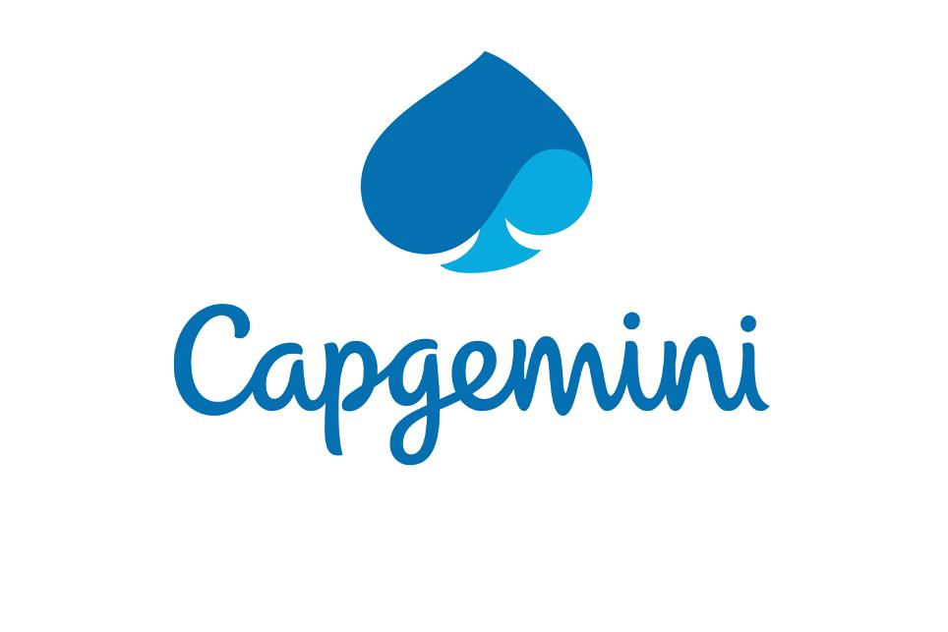

**SRS Document**

September 2018

1. **INTRODUCTION**

The purpose of this document is to build a networking web application where every user can get themselves connected with other users along with organizations globally.

**INTENDED AUDIENCE AND READING SUGGESTIONS**

This is a prototype of a social networking application similar to LinkedIn.

**Purpose**

The purpose of this application is to provide a platform where every users can share their feedbacks, thoughts and opinions. Organizations can post their job vacancies and users can apply for that post.

## 2. OVERALL DESCRIPTION

This web application is a [social networking](https://whatis.techtarget.com/definition/social-networking) site designed specifically for the business community. The goal of the site is to allow registered members to establish and document networks of people they know and trust professionally.

A user’s profile page, which emphasizes skills, employment history and education, has professional network news feeds and a limited number of customizable modules. To get in touch with other users, this application requires them to be connected. If a user accepts connection request from another user, only then both of them can view each other’s posts and their profile. In addition, the user can agree with the post of other user by liking his/her post or can also share their own view-point by commenting on that post.

This application provides a chatting component, using which the user can communicate privately with his/her connections.

Besides, this application has a company module, where various organizations can create their profile, after which can post for vacancies or recruitment details. Any user following that company can view/apply for the jobs.

**USER CLASS and CHARACTERISTICS**

1. Anyone wishing to be a part of this virtual network can register with his/her valid credentials and prior to verification of his email id, he can become a member of this network.
2. User can get redirected to his profile and home page after he successfully authenticates his login details. Upon forgetting his details, a verification link will be generated and sent to the registered email from which he can retrieve his account.
3. User can view post or profile of other user after creating a connection with another user. The user can send connection invitation to any user, where the invited user can either accept his connection or reject.
4. If any user accepts connection invitation from any other user, then both of them can view each other’s profile and posts.
5. User can share their thoughts, opinions or view-points as posts.
6. User can view posts of their connections can like or unlike the posts, comment on that post, can edit their existing post or even delete it.
7. User can chat with any of his/her connections using the chat module.
8. User can update his personal information.
9. User can endorse anyone from his connections.
10. User can block or unblock any user.
11. User can search for any other user or company who have their account in this application.
12. Apart from users, any organization can also create their official account by providing their details.
13. Organizations can post job requirement or vacancies.
14. User can follow organizations and apply for jobs posted by the organizations.

**OPERATING ENVIRONMENT**

Operating environment for the advertisement management system is as listed below.

* client/server system
* Operating system: Windows.
* database: Mongo dB
* front-end: Angular Framework, React JS library, Bootstrap,
* backend: Express JS
* Server system: Node JS

## 3. EXTERNAL INTERFACE REQUIREMENTS

**USER INTERFACES**

* Front-end software: Angular, ReactJS
* Back-end software: Mongo DB

**HARDWARE INTERFACES**

* Windows
* A browser which supports CGI, HTML & JavaScript. i.e. Internet Explorer 9 and above

**SOFTWARE INTERFACES**

Following are the software used for the advertisement management online application.

|  |  |
| --- | --- |
| **Software used** | **Description** |
| Operating system | We have chosen Windows operating system for its best support and user-friendliness |
| Database | To save the Advertisement records, user records we have chosen Mongo DB database |
| Angular JS and React JS | To implement the project we have chosen Angular and React framework for its more interactive support. |

**COMMUNICATION INTERFACES**

This project supports all new web browsers and I.E 9 and above. We are using simple html forms and bootstrap tables to showcase data.